

**PROTOCOL**to exercise

***Wireshark***

|  |  |  |
| --- | --- | --- |
| Group / Class | Secretary | Signature |
| 5 / **3BHEL** | **HOFSTÄTTER A.** |  |
| Exercise- / Delivery date | Employee | Signature |
| 17th March 2014 |  |  |
| Teacher | Employee | Signature |
| GRASINGER |  |  |
| Grade | **Employee** | Signature |
|  |  |  |
| ***Wireshark*** | | |
| **Used Programs**   |  |  |  |  |  | | --- | --- | --- | --- | --- | | Nr. | Device | Manufacturer | Type | Version | | 1. | **Wireshark** | **-** | **Tool** | 1.10.5 | | | |

Task

Describing the following commands:

1. Ipconfig /all
2. ping
3. tracert

1.) Ipconfig /all

This command is used to display all current network configurations. With “/all” you get more details.

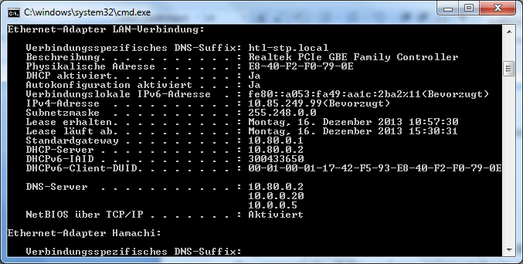

*Fig.1: Ipconfig/all a very small part of the whole command*

In this part of the command you can see my current ip address, standard gateway etc…

2.) Ping

Ping is a simple command which is sending a package to an ip address and tests the connectivity. If the package arrives at the ip address a response will be send back.

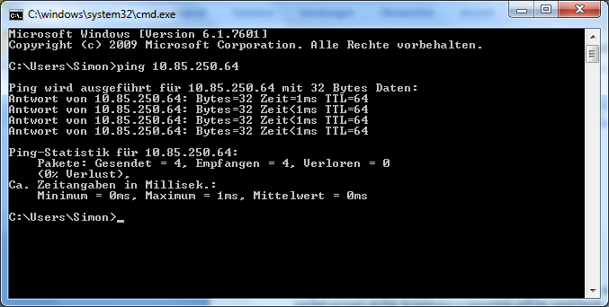

*Fig.2: Ping command to Lorenz Hirsch*

Normally 4 packages will be send. You can also see the time, the size of one package and how many packages arrived.

Wireshark is able to capture all pings and other traffic.

*Fig.3: A ping captured with wireshark*

3.) Tracert

Tracert (also called Traceroute) is a program which calculates the route of a package. It tells which router and internet knots ip data packages it had to pass to arrive at the computer.

traceroute to wikipedia.de (130.94.122.197), 30 hops max, 40 byte packets

1 fli4l.Netz1 (192.168.0.1) 0.765 ms 0.651 ms 0.497 ms

2 217.5.98.7 (217.5.98.7) 14.499 ms 14.648 ms 21.394 ms

3 217.237.152.46 (217.237.152.46) 14.831 ms 13.655 ms 13.403 ms

4 62.154.14.134 (62.154.14.134) 118.090 ms 119.522 ms 119.665 ms

5 p16-1-0-3.r20.asbnva01.us.bb.verio.net (129.250.9.141) 117.004 ms 117.370 ms 117.073 ms

6 p64-0-0-0.r21.asbnva01.us.bb.verio.net (129.250.2.35) 119.105 ms 119.284 ms 119.206 ms

7 p16-0-1-2.r20.plalca01.us.bb.verio.net (129.250.2.192) 180.035 ms 195.498 ms 178.704 ms

8 p16-1-0-0.r06.plalca01.us.bb.verio.net (129.250.3.81) 177.280 ms 177.263 ms 176.692 ms

9 p4-0-3-0.r00.sndgca01.us.bb.verio.net (129.250.3.10) 194.322 ms 193.477 ms 193.743 ms

10 ge-1-1.a03.sndgca01.us.da.verio.net (129.250.27.84) 192.527 ms 193.003 ms 192.464 ms

11 Pliny.wikipedia.org (130.94.122.197) 192.604 ms 193.875 ms 194.254 ms

*Fig.4: Short sample of traceroute*